A

Project Report

On

“Blood Donation”

Prepared by

Tanvi Gakhar (1992591)

Kamaljit Kaur (1992622)

Sarbjit Kaur (1992849)

Under the guidance of

Mr. Yash Sheth



August 2019

Contents

1 PROJECT DESCRIPTION 4

2 FUNCTIONAL COMPONENTS OF THE PROJECT 5

3 MODULES 7

4 HARDWARE AND SOFTWARE REQUIREMENTS 7

5 SCOPE OF PROJECT 8

6 PROBLEM FORMULATION 9

8 CONCLUSION & FUTURE SCOPE 12

9 References:- 13

# 1 PROJECT DESCRIPTION

This project deals with the “Blood Donation” to donate and receive blood. This App can be used to store the details of the users who want to receive or donate the blood, update the logs based on the current details etc. This is one integrated system that contains both the user component (used by user to enter their personal details) and the admin component (used to administer the logs and users). Main purpose is to provide fast medical service to the users at their door steps.

This App runs on multiple Smart Phones and Tabs, offers a GUI interface to its users and connects to a common database(s).

1. This system provides the following features:-

2. Join with app

3. Login to appSearch donor using location and blood group wise

4. Edit their personal details

5. Delete Account

6. View donor on map

# 2 FUNCTIONAL COMPONENTS OF THE PROJECT

Following is a list of functionalities of the system. More functionality that you find appropriate can be added to this list. And, in places where the description of functionality is not adequate, you can make appropriate assumptions and proceed. There are registered people in the system (donors or receivers). Each one of them may have some exclusive privileges (admin, for example, could create new users to the system whereas others cannot).

**(a) A Donor/Receiver should be able to**

1. User can register with app.

2. Login to the system through the initial screen of the system (by filling the form).

3. Change the password after logging into the system.

4. Maintain his profile periodically (by giving details of blood group).

5. Check the continuous events or camps of blood donation.

6. Communicate with the receivers.

7. Get the location of the receiver.

8. Search donor using location and blood group wise

9. Delete account

10. View donor on map

**(b) The administrator should be able to:**

1. login to the system and change his password after logging in

2. add new users to the system

3. Unsubscribe users from the system

4. Maintain the logs and keep the privacy policies for the user 5. Provide the forgotten password to the user

6. Provide the Blood donation camps related details to the donors

7. Email the Donors/Receivers

8. Add new events (Different blood donation camps)

# 3 MODULES

The modules for project are:

1. User Account Maintenance

2. Admin

3. User

# 4 HARDWARE AND SOFTWARE REQUIREMENTS

**(i) Hardware requirements:**

|  |  |  |
| --- | --- | --- |
| Number | Description | Alternatives(if available) |
| 1 | PC with 20 GB hard disk and 4 GB RAM | Not Applicable |

**(ii) Software requirements:**

|  |  |  |
| --- | --- | --- |
| **Number** | **Description** | **Alternatives (If available)** |
| 1 | Windows 7/8/XP with MS-  office | Not Applicable |
| 2 | MY-SQL |  |
| 3 | Java IDE |  |
| 4 | JDK 1.6 |  |
| 5 | Android Studio |  |

# 5 SCOPE OF PROJECT

Blood Donor Directory is aimed at developing a system to donate and receive blood. Simple searching option to view the Blood Donors in a specific area to contact in case of emergency. This is one integrated system that contains both the user component (used by user to enter their personal details) and the admin component (used to administer the logs and users). Registered users will be provided with the details about the different blood donation camps being operated. Also the non registered users can search for the donor’s by selecting the city and the blood group required. All the information will be provided to people searching for the blood donors.

There are four basic users :

1. Admin

2. Blood Banks, Hospitals, Clinics etc.

3. Blood Donors

4. Non-Members

1. All users have their own profiles in Online Blood Donor Database.

2. Blood Banks, hospitals, clinics could browse for blood donors in their nearby area.

3. Admin has the authority to add/delete users, grant permission to Blood Banks, Hospitals, Clinics and Donors to generate and view reports. He also can add events to the system like nationwide blood donation camps etc.

# 6 PROBLEM FORMULATION

**2.2.1 KEY TASKS OF THE PROJECT**

1. To prepare database.

2. To prepare stored procedures.

3. To prepare Business Logic Layer.

4. To prepare web pages.

5. To handle the control navigation from other pages

6. Writing the Code Behind pages for the web pages.

**2.2.2 MODULES OF BLOOD DONOR DIRECTORY**

The project consists of following modules:

1. User Account Maintenance

2. Admin

3. User

**2.3 OBJECTIVE OF THE PROJECT**

Proposed system is fully automated and web based system which provides user the better services. Users are provided with the user name and password and can access there account anytime. The system is fully computerized and is fast. This project mainly helps to manage the records of donors and receivers so that receivers have great flexibility to receive the blood. Regular updates for the blood camps organized will be provided to the users who have registered to the system.

1. A easy mouse based provision for adding & editing records
2. A strong database allows efficient searching, inserting & updating
3. Ultra friendly GUI interface
4. 4. Faster response time
5. Application Lifecycle

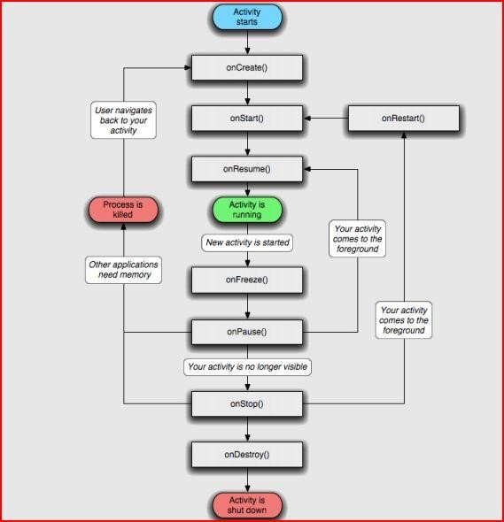

Figure :Flowchart Showing The Lifecycle Of An Activity

In Android, every application runs in its own process, which gives better performance in security, protected memory and other benefits. Therefore, Android is responsible to run and shut down correctly these processes when it is needed. It is important that application developers understand how different application components (in particular Activity, Service, and Broadcast Receiver) impact the lifetime of the application's process. Not using these components correctly can result in the system killing the application's process while it is doing important work. To determine which processes should be killed when low on memory, Android places each process into an "importance hierarchy" based on the components running in them and the state of those components.

1. Screenshots

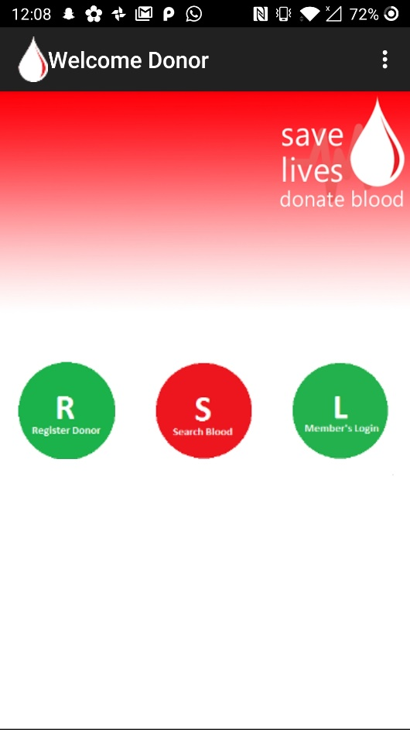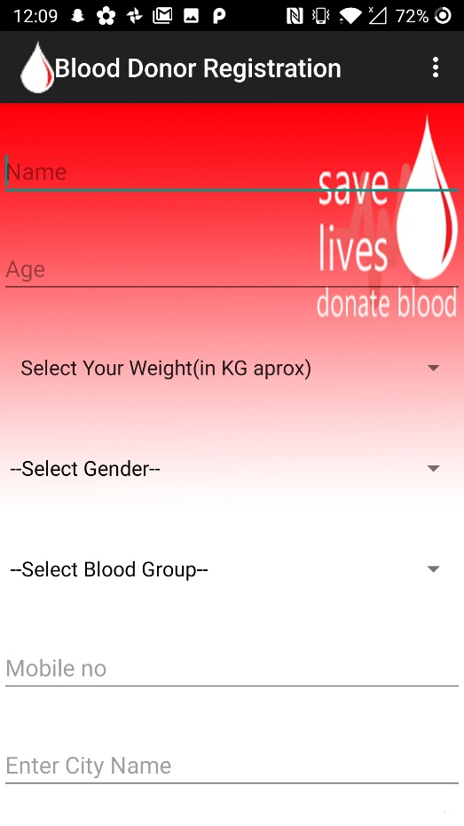

**Home activity Register activity**

# 

# 

# Login Activity Blood donor detail activity

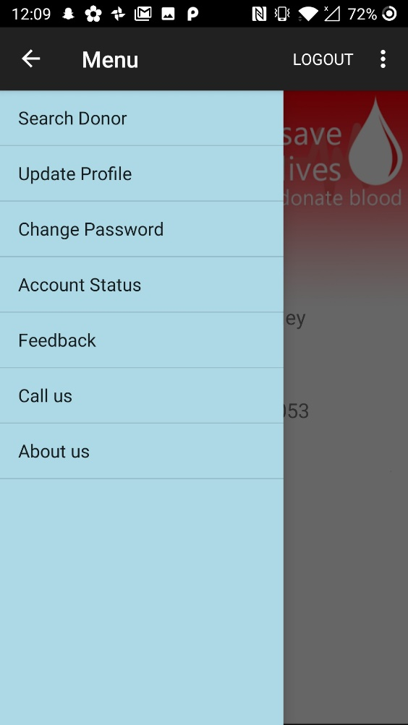 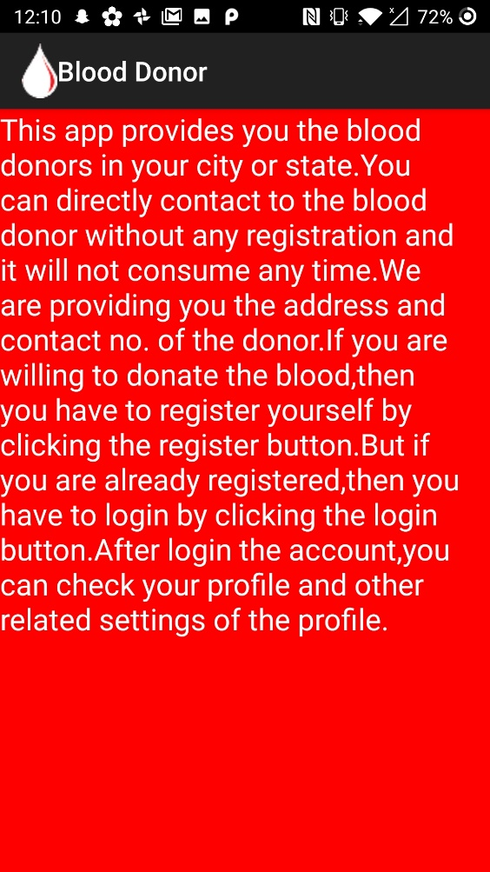

Menu Activity Help Activity

# 8 CONCLUSION & FUTURE SCOPE

**Conclusion**

As a member of the team under the guidance of my trainer, I have been educated about the java technologies .The particular area of to which my project serves extremely helpful. I am required to understand and learn the intricacy involved in this area. I would design input interfaces, design database, develop code, input test data, output interfaces, and output test data. Completion of the development process will result in a software package that will provide user friendly environment which is very easy to work with, even for people with very little knowledge of computer. Management of various tasks is incorporated in the package and will deliver the required information in a very easy to use and easy to access manner.

This package will provide accuracy, efficiency, speed and easiness to the end user.

**Future Scope**

The primary concern of every system client is validity of the purchased software product in the near future. In order to cope with this problem, programmers often provide their clients with regular system updates so that in case there have been any change include in working criteria of institution/organization, it can be absorbed within existing automated system. I have compiled this project keeping this point in full regards that it can be easily upgraded if need arises. From time to time, new modules can be added to it or existing ones can be modified.

Depending upon the organization, the function processes and needs may vary from organization to organization. Therefore, the functionality of the project can be further enhanced as per the requirements specification of different organization. For instance, any organization can use this project by just changing the interest rate accordingly and the rest of the operations will be remained same. Similarly, the project can be expanded to the required extent.

# 9 References:-

1. Core java fundamentals
2. The complete java reference
3. Android Apps for absolute beginner written by wallance Jackson.